# CS 255 System Design Document Template

This template lays out all the different sections that you need to complete for Project Two. Each section has guidance to prompt your thinking. You will need to continually reference the interview transcript as you work to make sure that you are addressing your client’s needs. There is no required length for the final document. Instead the goal is to complete each section based on what your client’s needs are. Remove this note when you are finished, and replace all bracketed text with the relevant information.

## UML Diagrams

### UML Use Case DiagramUse case diagram.pdf

### UML Activity Diagrams

*[You were asked to choose* ***two*** *use cases and create* ***two*** *activity diagrams, one for each use case. Please insert* ***both*** *of your activity diagrams here. Check to make sure that you included appropriate components and symbols and that your design meets the client’s needs.]*

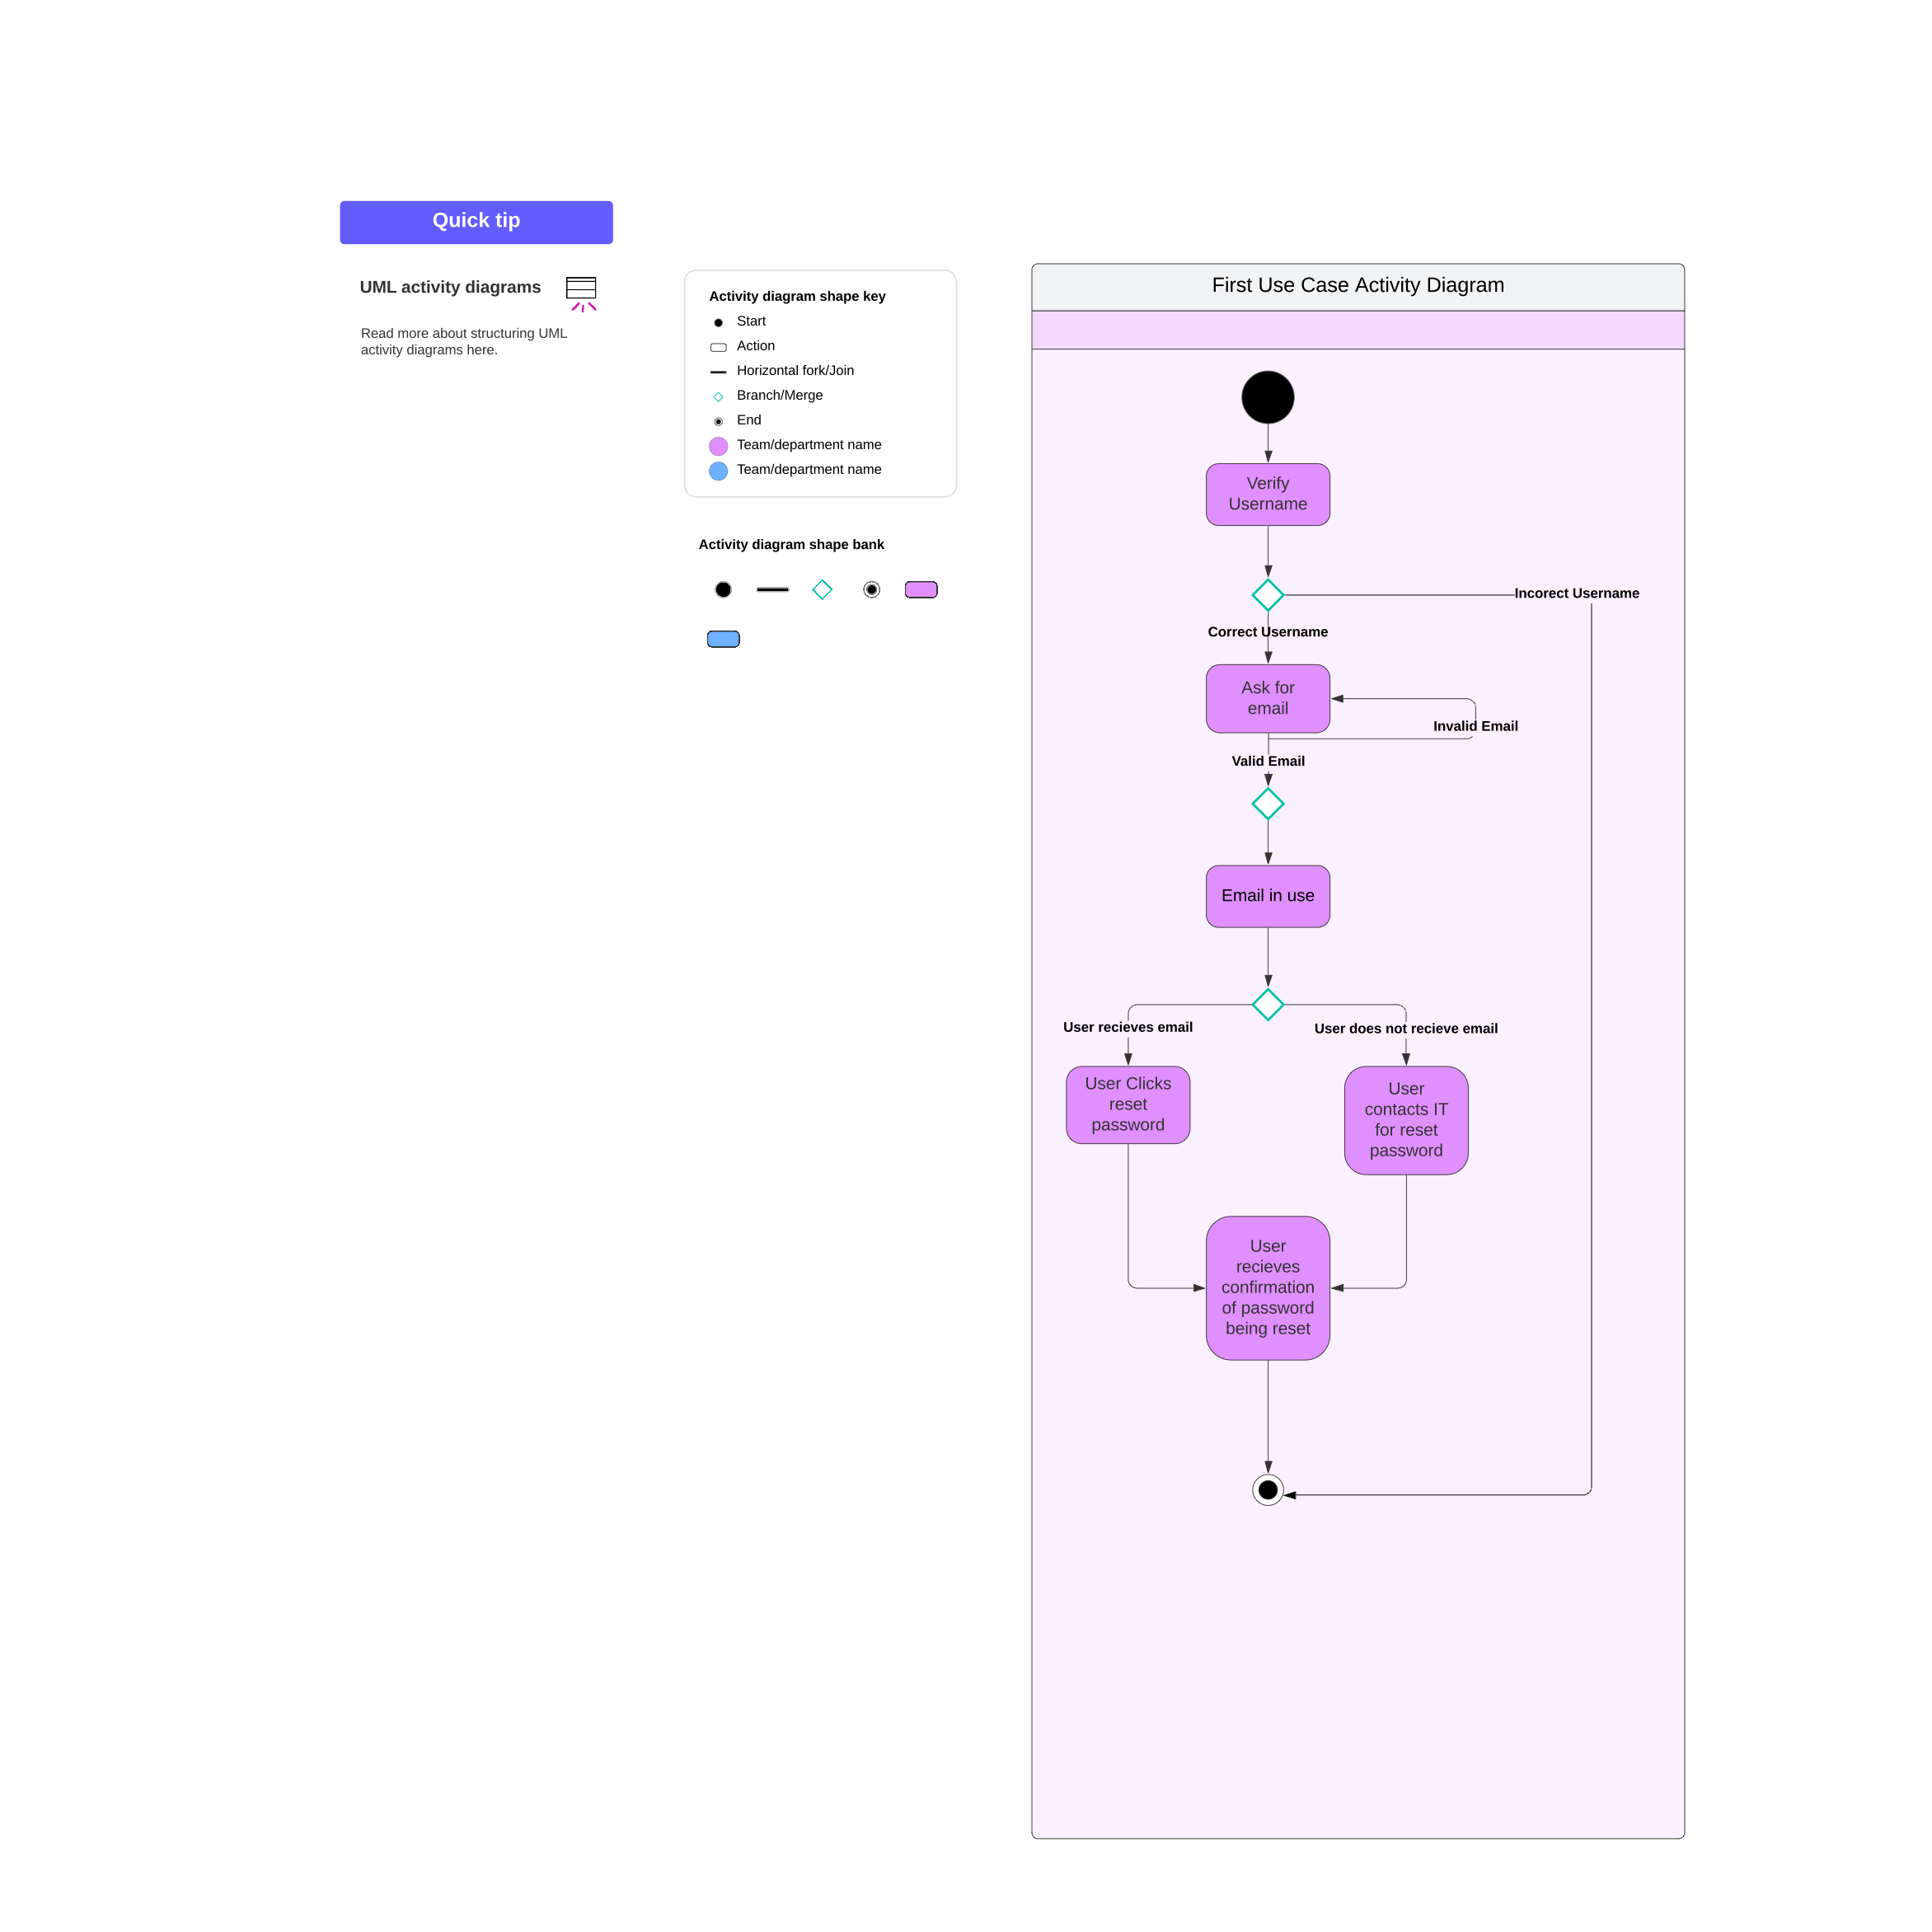

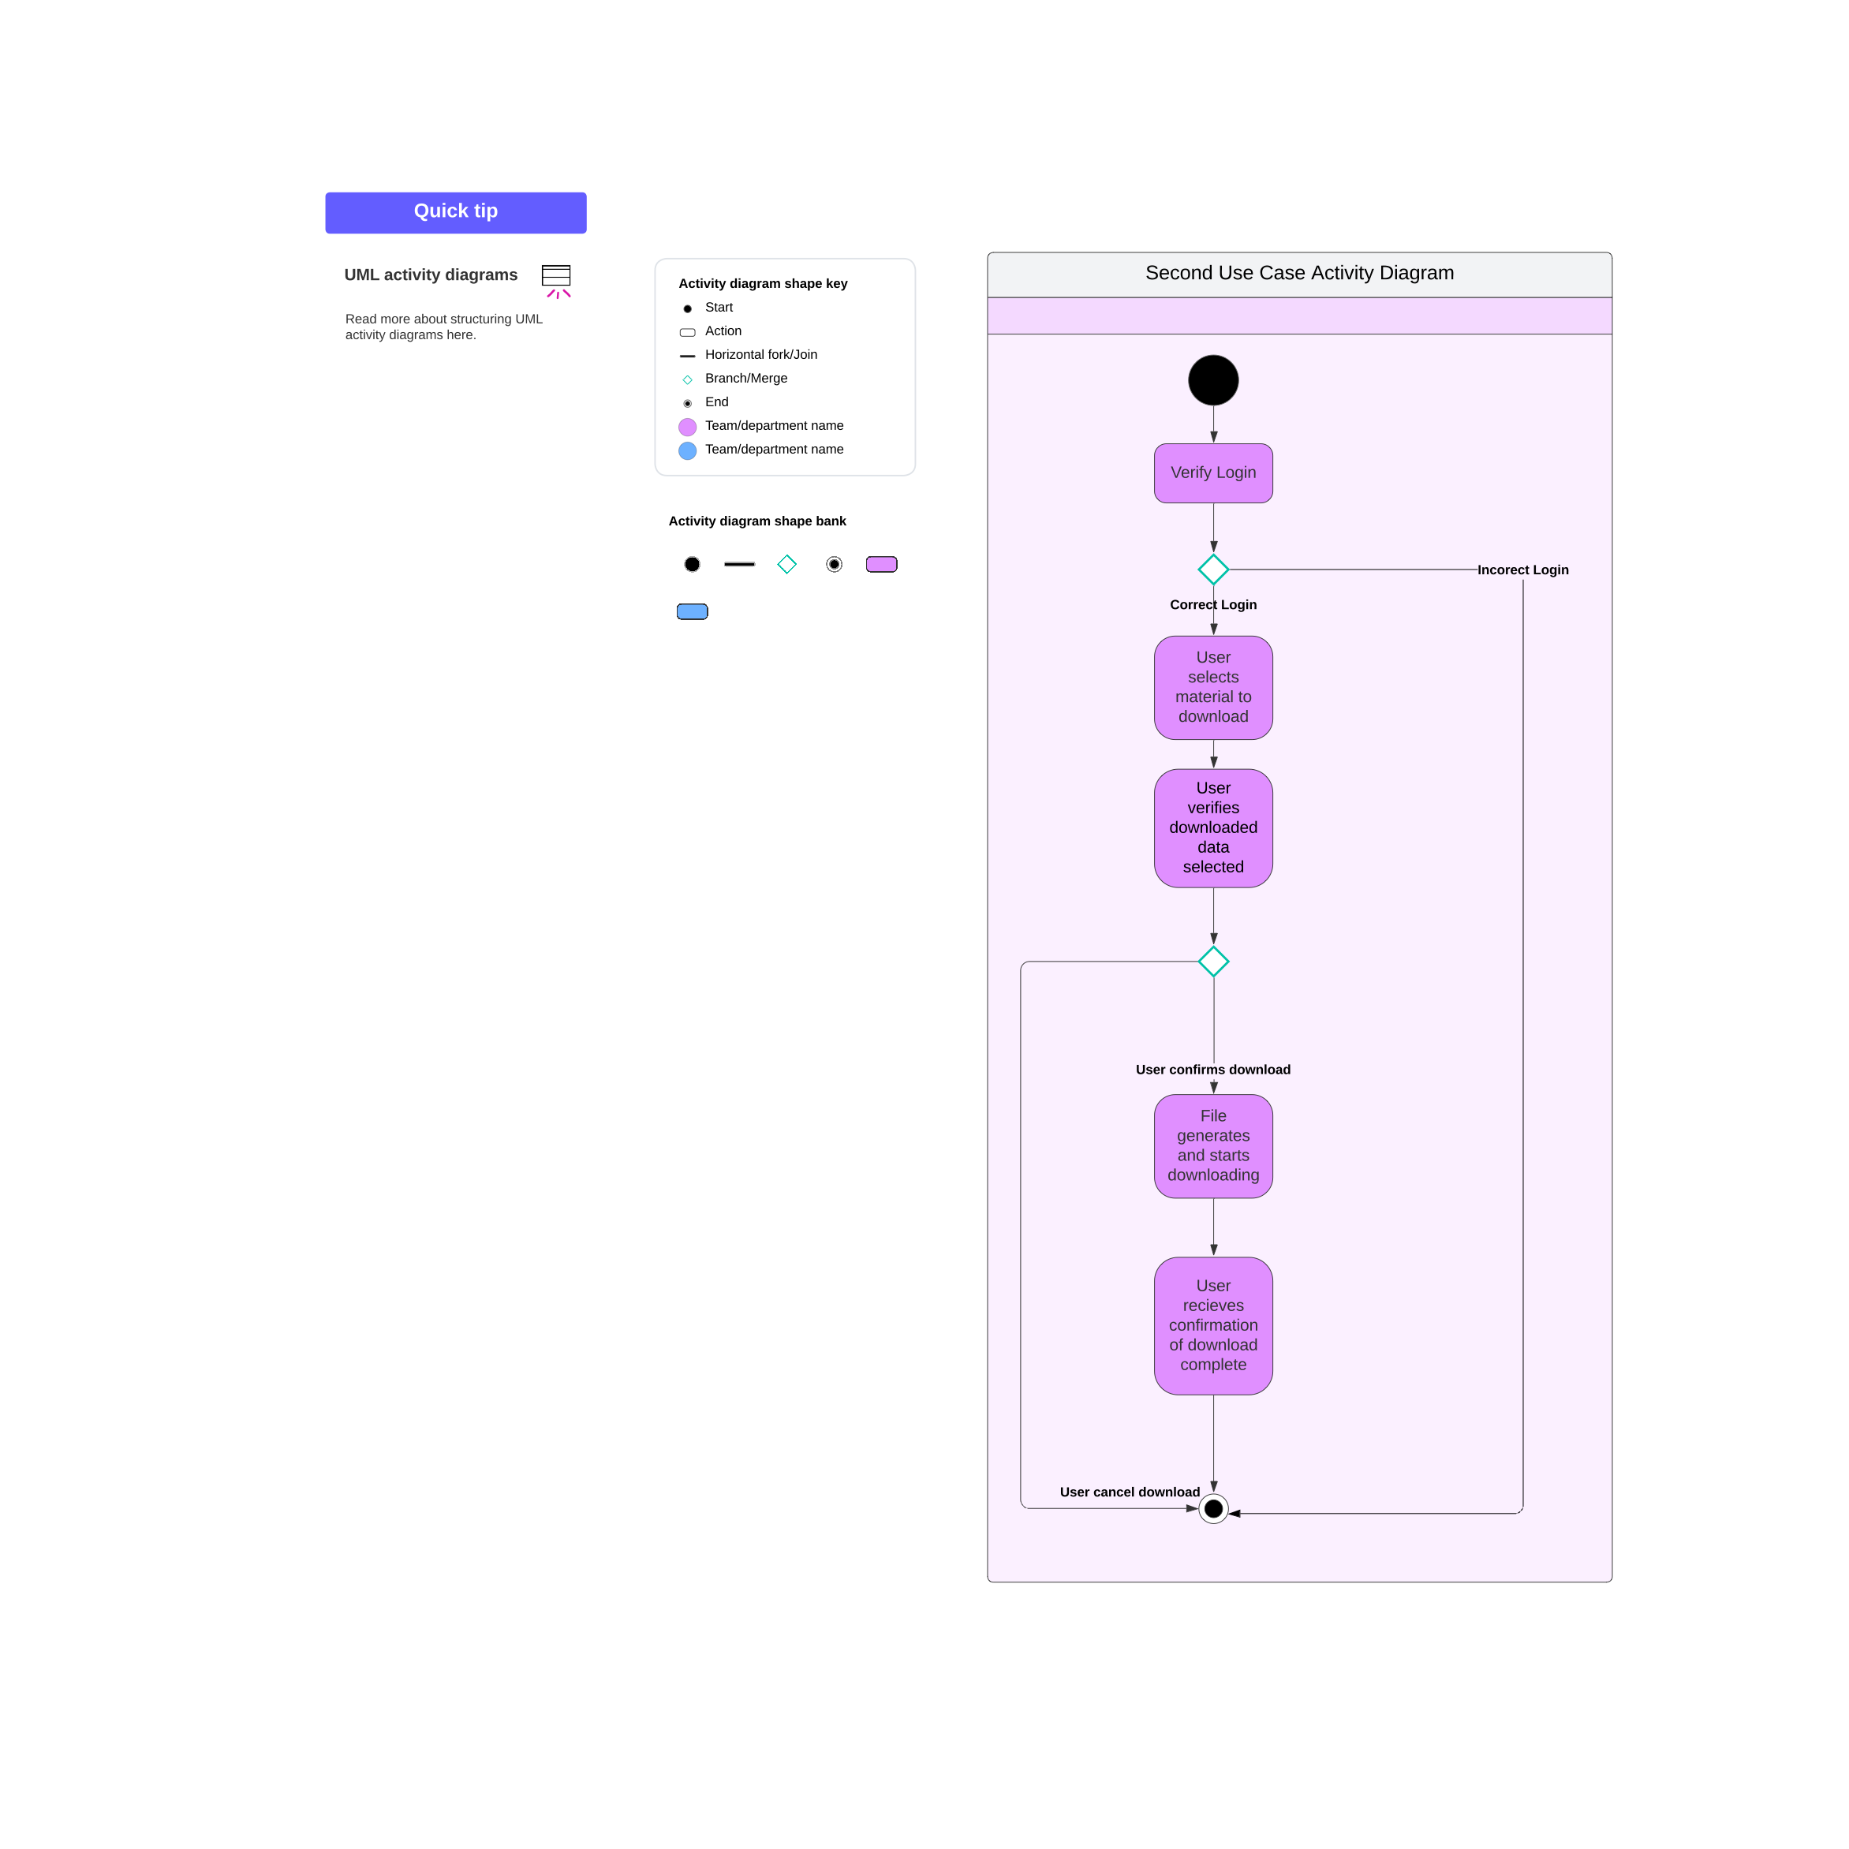

### UML Sequence Diagram

*[You were asked to create a sequence diagram based on* ***one*** *of the use cases you chose. Please insert your sequence diagram here. Check to make sure that you included appropriate components and symbols and that your design meets the client’s needs.]*

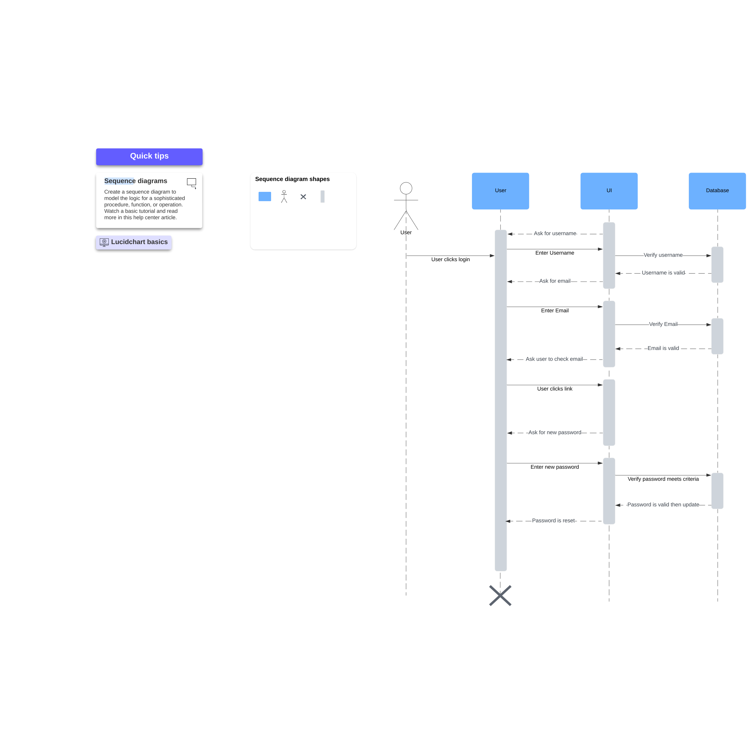

### UML Class Diagram

*[You were asked to create a class diagram based on the different classes and attributes needed for your system design. You are* ***not*** *required to include methods, but you may if you wish. Please insert your class diagram here. Check to make sure that you included appropriate components and symbols and that your design meets the client’s requirements.]*

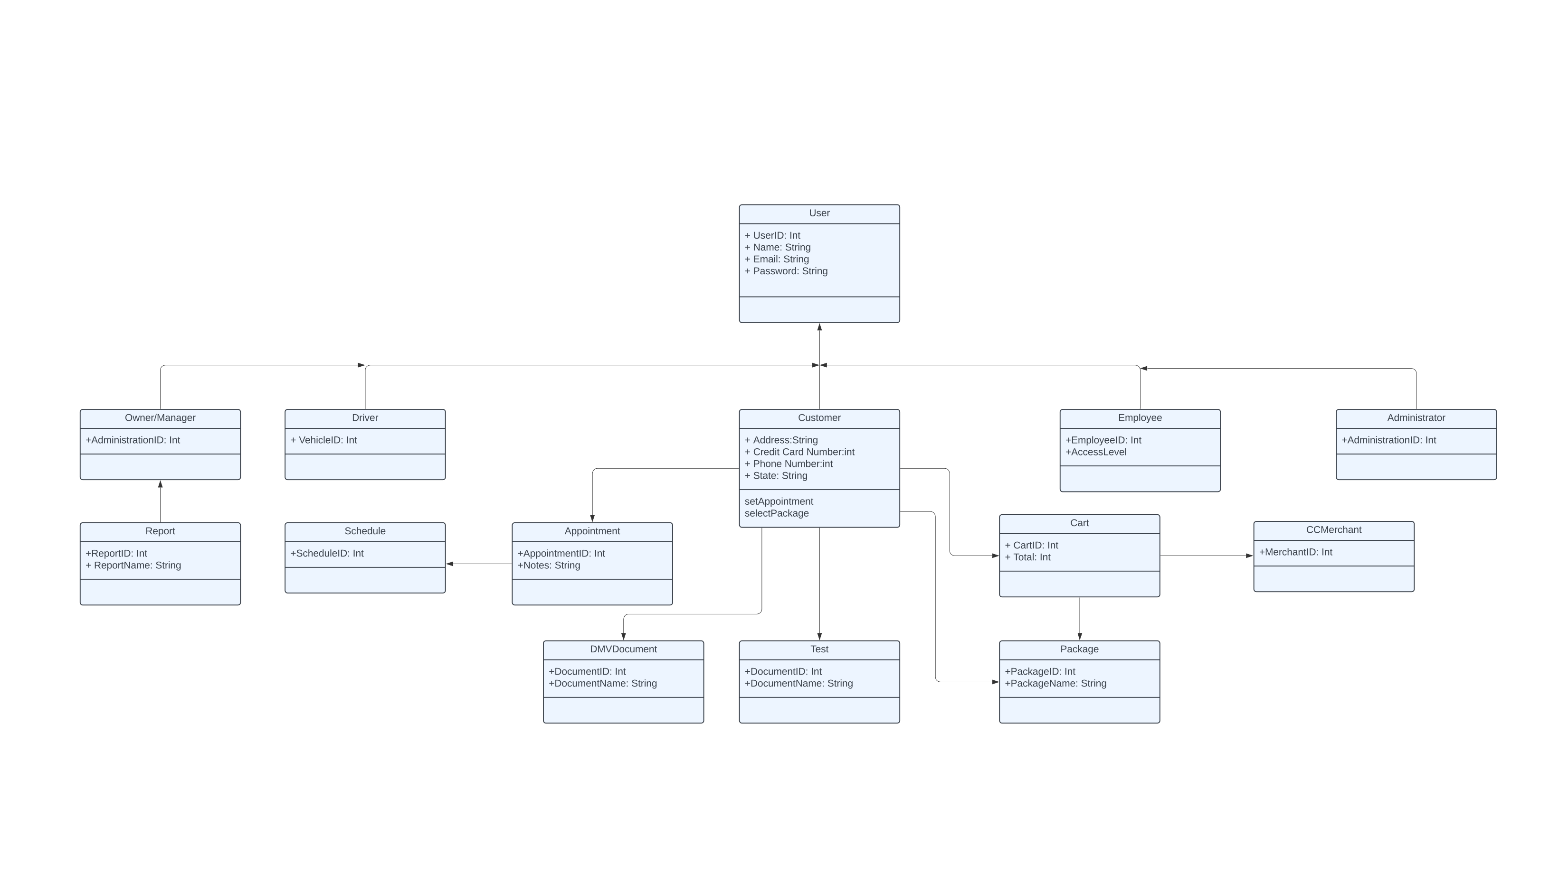

## Technical Requirements

*[Based on the diagrams you have created, describe the technical requirements of your system. These requirements should address the required hardware, software, tools, and infrastructure necessary for your system design.]*

Our system requires a robust set of technical capabilities to ensure efficiency, security, and accessibility. Firstly, the system will be developed for both web and mobile platforms, utilizing cloud technology to enable real-time data access and updates. The mobile application will allow the owner to access critical information and manage data on the go, ensuring flexibility and responsiveness.

A secure and scalable database is essential for storing sensitive information such as login credentials and other critical data. This database could either be hosted on a cloud-based platform or within a physical data center, depending on the specific needs and infrastructure of the organization.

To safeguard data integrity and security, all data transmitted between users and the system, as well as internally within the system, will be encrypted using SSL (Secure Sockets Layer). This encryption is vital to protect against unauthorized access and ensure that all information remains confidential.

The adoption of a cloud platform will also facilitate faster updates and seamless synchronization of information. For instance, features like the training calendar for scheduling appointments and the training progress tracker will be able to update in real-time, enhancing user experience and operational efficiency.

Additionally, implementing role-based access control is crucial. This feature will ensure that different users have access to the appropriate levels of functionality. For example, the system owner will have full access, while customers, IT officers, secretaries, and other roles will have permissions tailored to their specific responsibilities, preventing unauthorized access to sensitive features and data.